**Module 8**

**Bootstrap Basic & Advanced**

**• What are the advantages of Bootstrap?**

Bootstrap is an open-source CSS framework designed to come up with mobile-friendly, responsive front-end web development.

Advantages of Bootstrap for Web Development

1. Easy Initiation

Coding is a hurricane task for who is unbeknownst to web development. But the greatest use of Bootstrap in web development is it makes coding hassle-free. Bootstrap handles everything for you.

1. Responsiveness

Statistics highlight over 6.4 billion smartphone users worldwide. This study infers smartphone penetration of over 80 percent.

1. Highly customizable

You can find an array of templates in Bootstrap. However, if you find them unappealing, you concoct your customization using the CSS file.

**• What is a Bootstrap Container, and how does it work?**

A Bootstrap Container is a fundamental element in the Bootstrap framework, which is a popular front-end development framework for building responsive and mobile-first websites and web applications. The Container is a class that is used to wrap and contain the content of a webpage within a fixed-width container.

Here's how it works:

1. **Fixed-width container**: The Container class in Bootstrap defines a fixed-width container for holding and aligning the content of a webpage.
2. **Responsive design**: Bootstrap Containers are designed to be responsive, meaning they adjust their width based on the screen size of the device viewing the webpage.
3. **Grid system alignment**: Bootstrap Containers work seamlessly with Bootstrap's grid system. The grid system allows developers to create responsive layouts by dividing the container into rows and columns.
4. **Padding and margin**: By default, Bootstrap Containers have a small amount of padding on the left and right sides to create space between the content and the edges of the container.

Here's an example of how a Bootstrap Container is typically used in HTML:

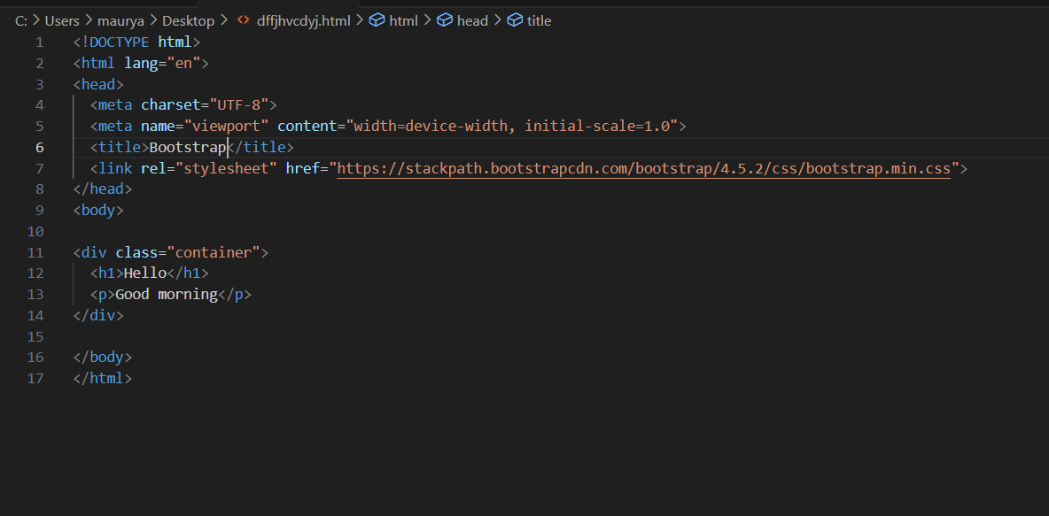

In this example, the container class is applied to a div element, creating a fixed-width container for the content within it.

Top of Form

**• What are the default Bootstrap text settings?**

Bootstrap provides default text settings to ensure consistency and readability across different devices and screen sizes. These default text settings include:

1. **Font family**: Bootstrap uses the system's default font family for displaying text. This ensures that the text looks consistent with the rest of the content on the device.
2. **Font size**: By default, Bootstrap sets the font size to 1rem (which is equivalent to 16px). This size is used for the base text size throughout the website or web application.
3. **Line height**: Bootstrap sets the line height for text to 1.5. This ensures adequate spacing between lines of text, enhancing readability.
4. **Font weight**: The default font weight for regular text in Bootstrap is 400 (normal). This provides a balanced weight for text content.
5. **Text color**: Bootstrap sets the default text color to #212529, which is a dark shade of gray. This color provides good contrast against most backgrounds, enhancing readability.
6. **Text alignment**: By default, text is aligned to the left. However, Bootstrap provides utility classes (text-center, text-right, text-justify, text-nowrap, etc.) to easily align text as needed.
7. **Text decoration**: Text decoration such as underline or line-through is not applied by default in Bootstrap.

These default text settings in Bootstrap ensure that text appears consistent and readable across different devices and screen sizes. Developers can customize these settings further using custom CSS if necessary.

**• What do you know about the Bootstrap Grid System?**

The Bootstrap Grid System is a powerful layout component provided by the Bootstrap framework, allowing developers to create responsive and mobile-first layouts easily. It's based on a 12-column grid system, which provides a flexible and efficient way to design web pages across various devices and screen sizes.

Here's what you need to know about the Bootstrap Grid System:

1. **12-column grid**: Bootstrap divides the webpage layout into 12 equal-width columns. This division provides flexibility in creating layouts with different column combinations.
2. **Rows and columns**: To use the grid system, you organize content within rows and columns. Each row can contain up to 12 columns.
3. **Responsive design**: The grid system is inherently responsive, meaning it automatically adjusts the layout based on the screen size of the device.
4. **Grid classes**: Bootstrap provides a set of grid classes to control the layout of content within columns. These classes include **col-**, **col-sm-**, **col-md-**, **col-lg-**, and **col-xl-**, which specify the column width at different breakpoints (extra small, small, medium, large, and extra-large screens, respectively).
5. **Offsetting and nesting**: Bootstrap allows developers to offset columns and nest rows within columns to create more complex layouts.
6. **Alignment**: Bootstrap provides classes to align content horizontally and vertically within columns. Alignment classes include **justify-**content-* for horizontal alignment and align-items-* for vertical alignment.
7. **Ordering**: Developers can change the order of columns at different breakpoints using the order-* classes. This feature is useful for rearranging content based on screen size or other considerations.
8. **Utility classes**: Bootstrap offers utility classes to control the visibility and display of content at different breakpoints. These classes include d-none, d-block, d-sm-none, etc., for controlling wthe display of content on various screen sizes.

Overall, the Bootstrap Grid System provides a flexible and intuitive way to create responsive layouts, making it a popular choice for web developers. Its simplicity and ease of use make it suitable for both beginners and experienced developers alike.

**• What is the difference between Bootstrap 4 and Bootstrap 5**

Bootstrap 4 and Bootstrap 5 are both popular front-end development frameworks, but Bootstrap 5 represents an evolution of the framework with several improvements and new features compared to Bootstrap 4. Here are some key differences between the two versions:

1. **Vanilla JavaScript**: Bootstrap 5 has shifted from jQuery to vanilla JavaScript for its components and plugins. This reduces dependencies on third-party libraries and makes Bootstrap more lightweight and efficient.
2. **Customization**: Bootstrap 5 offers enhanced customization options compared to Bootstrap 4. It provides a new customization tool called "Bootstrap Icons" that allows users to select only the components they need, resulting in smaller file sizes and improved performance.
3. **Utility classes**: Bootstrap 5 introduces additional utility classes, making it easier to style elements without custom CSS. It includes new utility classes for spacing, typography, color, and more, providing greater flexibility in styling.
4. **Grid system improvements**: While both versions utilize a 12-column grid system, Bootstrap 5 enhances the grid with new features such as column gap support and improved vertical alignment options.
5. **Improved form components**: Bootstrap 5 introduces new form components and enhancements, including floating labels, validation styles, and custom form controls.
6. **Accessibility**: Bootstrap 5 prioritizes accessibility by providing better keyboard navigation and focus styles, ensuring that websites built with Bootstrap are more accessible to users with disabilities.
7. **Documentation and community**: Bootstrap 5 offers updated documentation with improved organization and clarity compared to Bootstrap 4. Additionally, the Bootstrap community continues to grow, providing more resources, tutorials, and third-party plugins for developers.

Overall, Bootstrap 5 builds upon the strengths of Bootstrap 4 while addressing limitations and introducing new features to improve usability, performance, and customization capabilities for developers.

**• What is a Button Group, and what is the class for a basic Button Group?**

A Button Group in Bootstrap is a group of buttons that are visually grouped together, typically to perform related actions or represent options within a user interface. Button groups help organize and present buttons in a cohesive manner, improving user experience and visual clarity.

The class for a basic Button Group in Bootstrap is **btn-group**. This class is applied to a container element, typically a **<div>** element, that wraps the buttons within the group. Here's an example of how a basic Button Group is structured in HTML using Bootstrap:

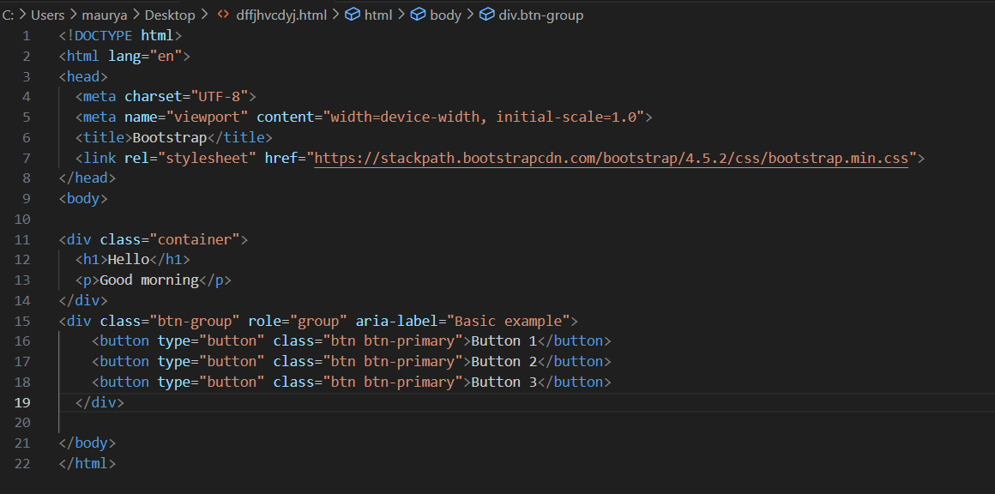

In this example:

* The <div> element has the class btn-group, indicating that it is a button group.
* Each button within the group has the class btn, indicating that it is a Bootstrap button component.
* The role="group" attribute is added to the container <div> to indicate that it serves as a group of related elements.
* The aria-label attribute provides an accessible label for screen readers, describing the purpose of the button group.

Button groups in Bootstrap can also be used with additional classes and attributes to create different variations, such as button dropdowns or segmented button groups, providing further flexibility in designing user interfaces.

**• How can you use Bootstrap to make thumbnails?**

In Bootstrap, you can create thumbnails using the **img-thumbnail** class along with the grid system to organize and display images in a grid-like format. Here's a basic example of how you can use Bootstrap to create thumbnails:

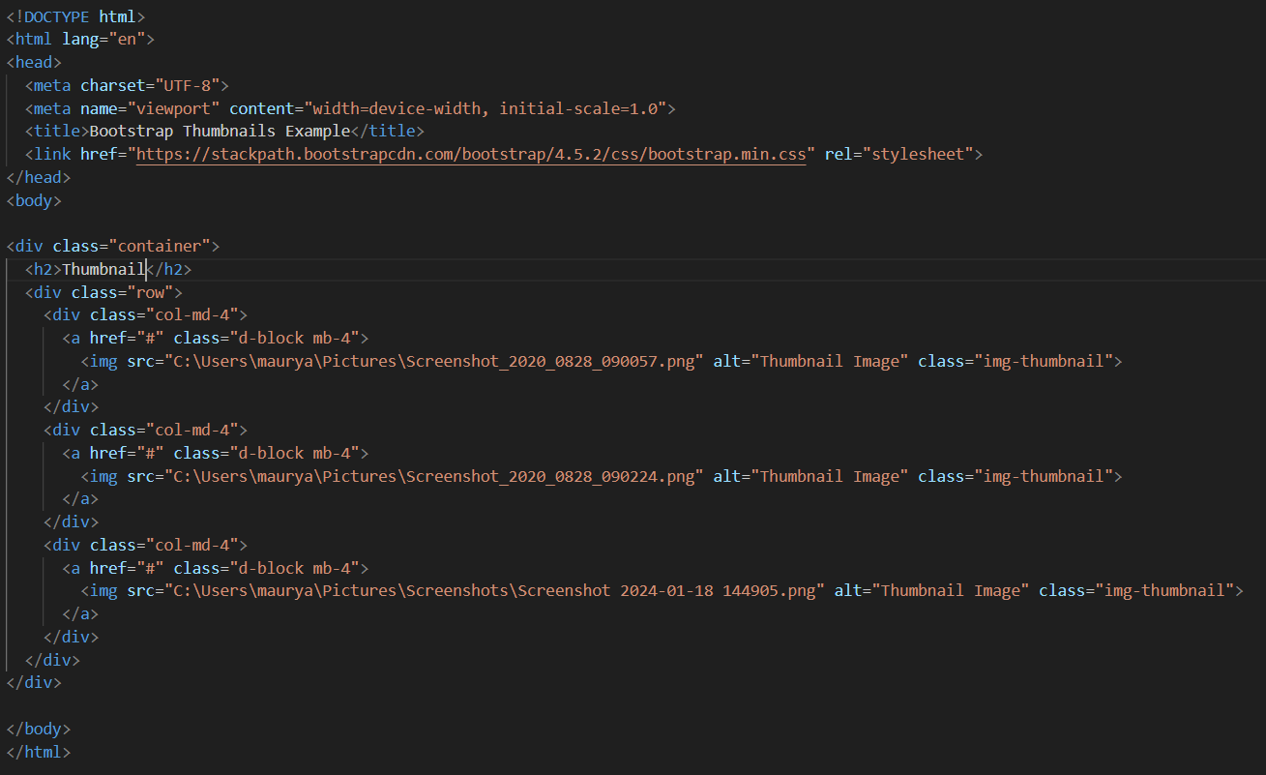

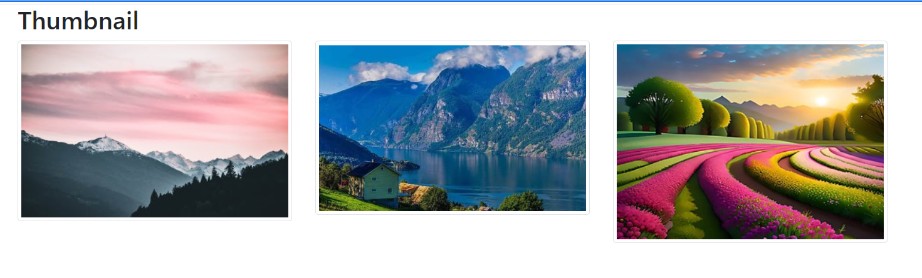

In this example:

* We've included the Bootstrap CSS file from a CDN (Content Delivery Network) to apply Bootstrap styling to our page.

Inside a container, we have a heading "Thumbnail Gallery" and a div with the class **row** to create a row for our thumbnails.

Within the row, we have three columns (col-md-4), each containing an image wrapped in an anchor (**a**) tag.

* Each image has the class img-thumbnail, which adds Bootstrap's styling to make it look like a thumbnail.

You can replace the placeholder image URLs with the URLs of your actual images. Additionally, you can customize the grid layout and styling as per your requirements by adjusting Bootstrap's grid classes and thumbnail styles.

**• In Bootstrap 4, what is flexbox?**

In Bootstrap 4, flexbox refers to the CSS Flexible Box Layout Module, which is a layout model designed to provide a more efficient way to distribute space and align items within a container, especially in responsive web design. Here are some key concepts and features of flexbox in Bootstrap 4:

1. **Container and items**: In flexbox, the parent element containing the flex items is known as the flex container, while the child elements within the container are called flex items.
2. **Main axis and cross axis**: Flexbox layouts operate along two axes: the main axis and the cross axis. The main axis is the primary axis along which flex items are laid out, while the cross axis is perpendicular to the main axis.
3. **Flex direction**: Bootstrap 4 allows you to specify the direction in which flex items are laid out within the flex container using the flex-direction property. The available options are row, row-reverse, column, and column-reverse.
4. **Flexibility and alignment**: Flexbox provides powerful alignment and spacing capabilities, allowing you to control the size, order, alignment, and spacing of flex items using properties such as justify-content, align-items, align-self, and flex.
5. **Responsive behavior**: Flexbox is inherently responsive, making it ideal for creating layouts that adapt to different screen sizes and device orientations. Bootstrap 4 utilizes flexbox to create responsive grid layouts that automatically adjust based on the viewport size.
6. **Utility classes**: Bootstrap 4 provides a range of utility classes for working with flexbox, allowing you to easily apply flexbox properties and behaviors to elements without writing custom CSS.

Overall, flexbox is a key feature of Bootstrap 4 that empowers developers to create flexible, responsive, and visually appealing layouts with ease. It simplifies the process of building complex designs while providing consistent and reliable results across different browsers and devices.

**• How can one create an alert in Bootstrap?**

In Bootstrap, you can create alerts using pre-defined alert classes. Alerts are useful for displaying important messages, notifications, warnings, or feedback to users. Here's how you can create an alert in Bootstrap:

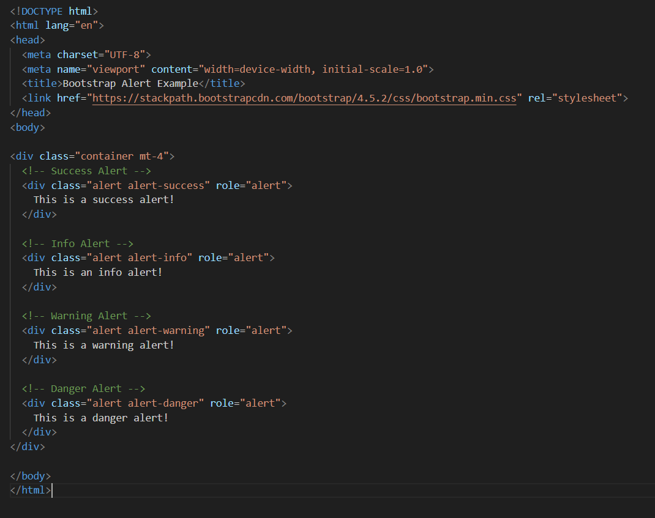

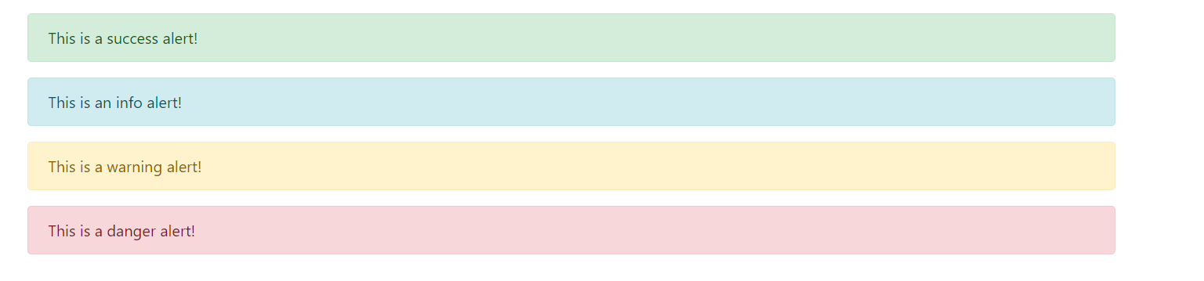

In this example:

* Each alert is enclosed within a **<div>** element with the class **alert**.
* The role="alert" attribute is added to improve accessibility by indicating to screen readers that the **<div>** contains an alert message.
* Inside each alert **<div>**, you can place the content you want to display, such as text, links, or buttons.

You can further customize alerts by adding additional classes or by combining them with other Bootstrap components. For example, you can add dismissible functionality to alerts by including the alert-dismissible class and a close button inside the alert. Additionally, you can style alerts with custom CSS to match your application's design.

**• What is a bootstrap card and how would you create one?**

A Bootstrap card is a flexible and extensible content container that allows you to display various types of content, such as text, images, links, buttons, and more, in a structured manner. Cards are a versatile component commonly used for presenting information in a visually appealing way. You can think of cards as small containers that encapsulate individual pieces of content.

Here's how you can create a basic Bootstrap card:

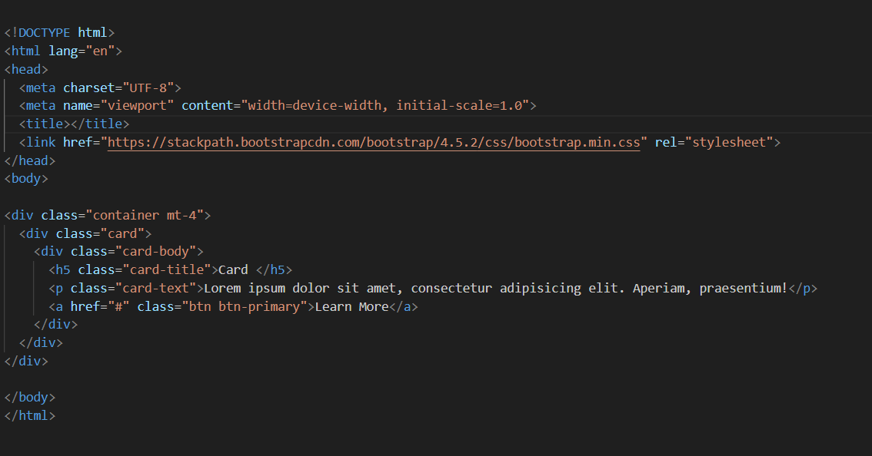

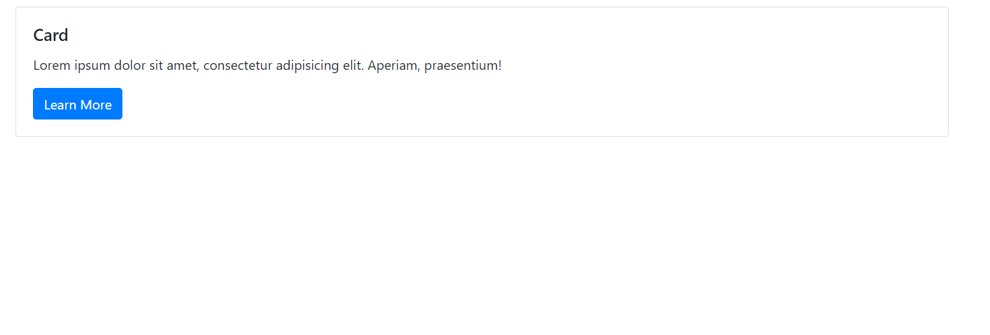

In this example:

* Inside the card container, there's a with <div> the class card-body, which contains the main content of the card.
* Bootstrap provides several utility classes to style the content within cards, such as card-title for the card title and card-text for the card content.
* You can further customize cards by adding additional classes or by combining them with other Bootstrap components, such as headers, footers, or navigation bars.

This is a basic example of a Bootstrap card. You can add more complexity to cards by including additional elements, styling them with custom CSS, or utilizing Bootstrap's JavaScript components for interactive functionality.